RAF Wycombe departure
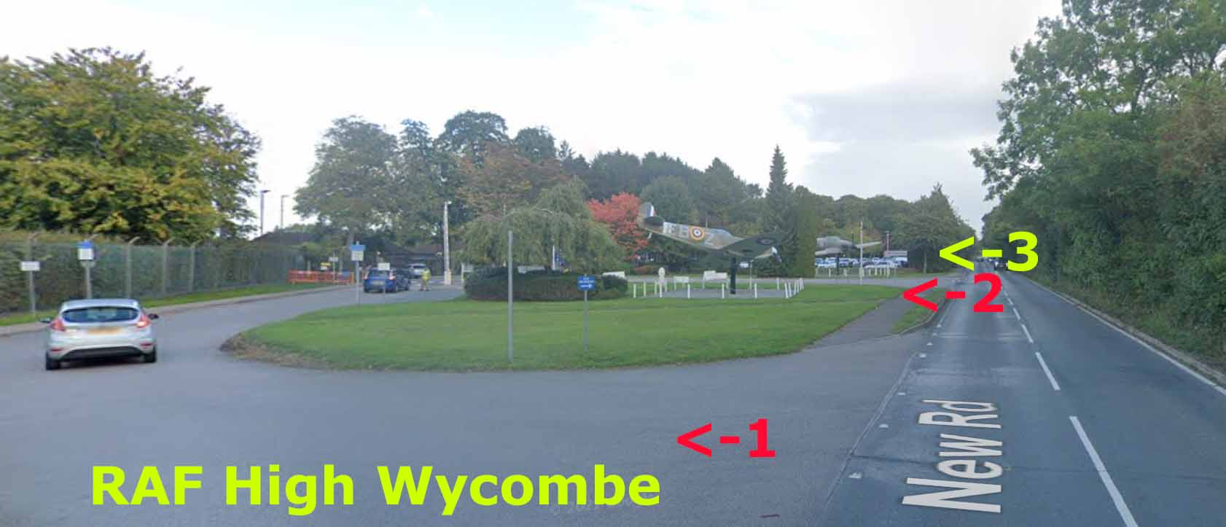
If arriving at RAF High Wycombe from Naphill use the Car Park entrance (3). The first entrance (1) takes you to the security gate DO NOT USE. The second entrance (2) is in front of the aircraft with concrete blocks preventing access DO NOT USE.
From the Risborough/Lacey Green the car park entrance is the first you encounter.
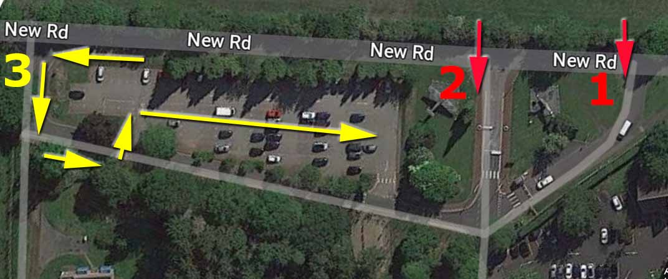

When leaving the RAF base exit right from the grounds
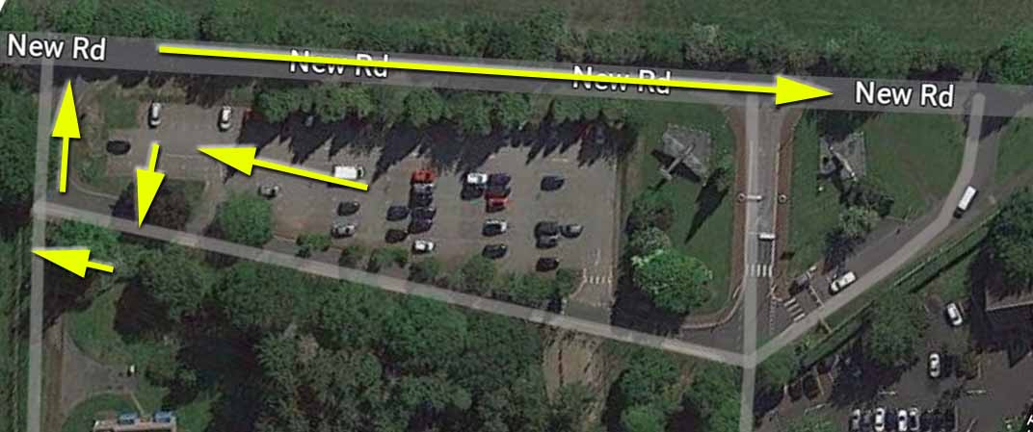
Follow the road through Walters Ash and Naphill villages and descend the STEEP HILL in to Hughenden Valley.
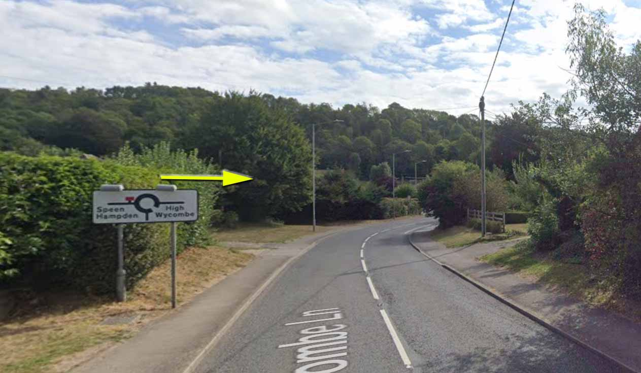
At the mini roundabout at the foot of the hill turn RIGHT for High Wycombe

It’s only a short distance to the next roundabout – take the A4128 to High Wycombe. Follow the A4128 all the way into Wycombe, pass Hughenden Manor on the right and continue until the big Arch Way roundabout after the railway arches.
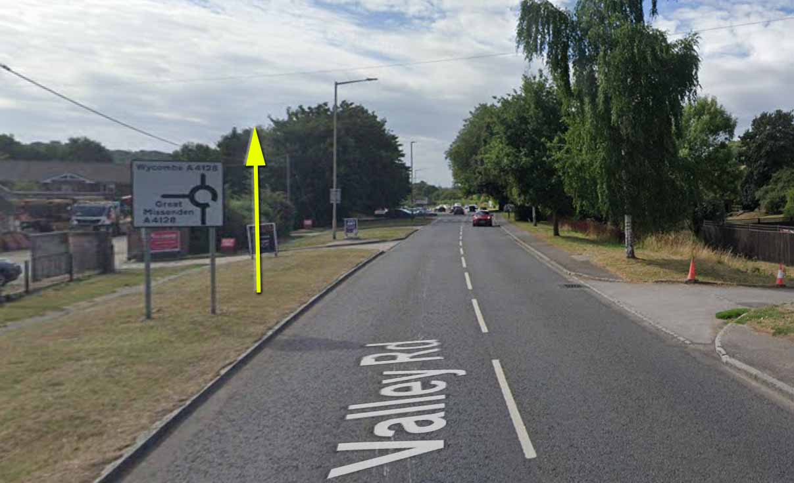
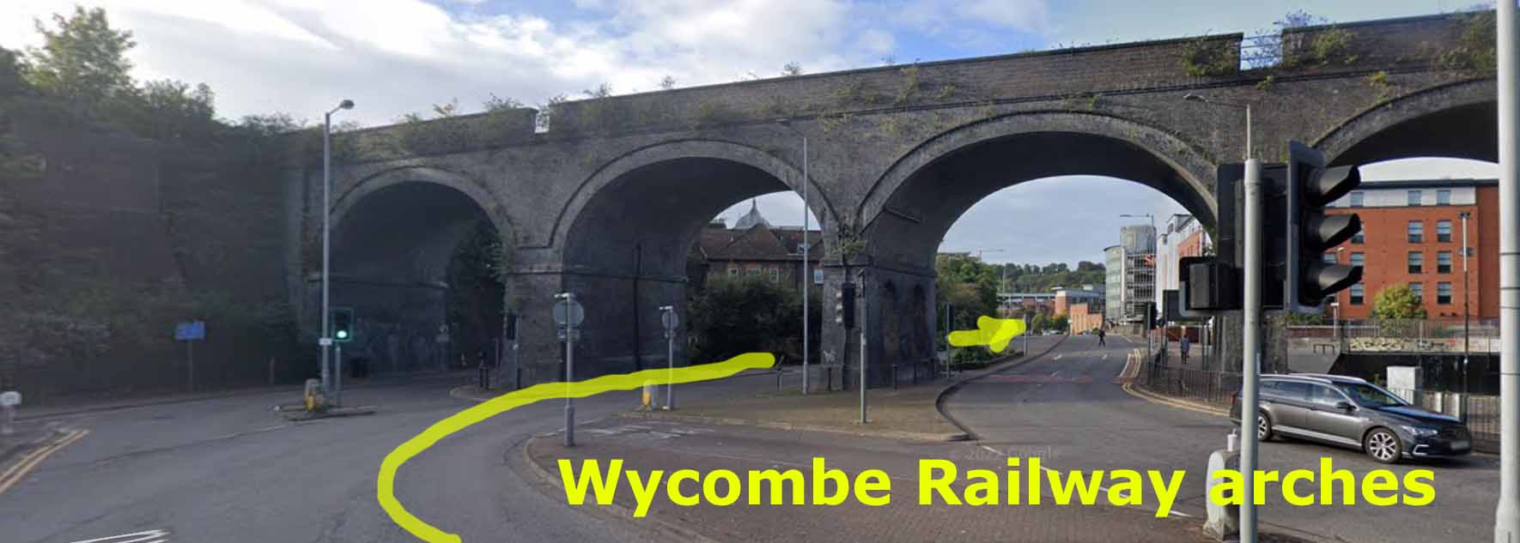
At the Arch Way roundabout after the arches turn right on to the A40 (signposted Aylesbury)
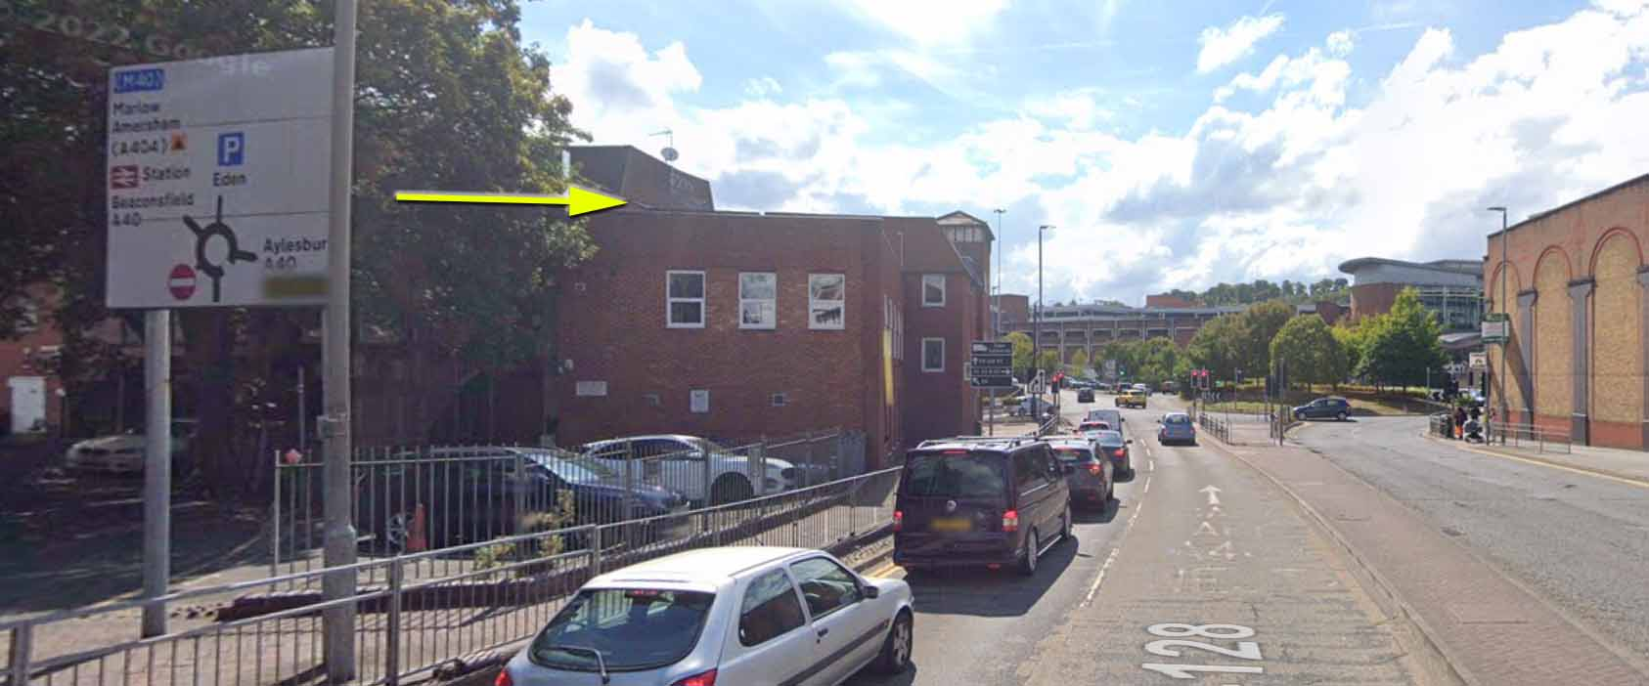
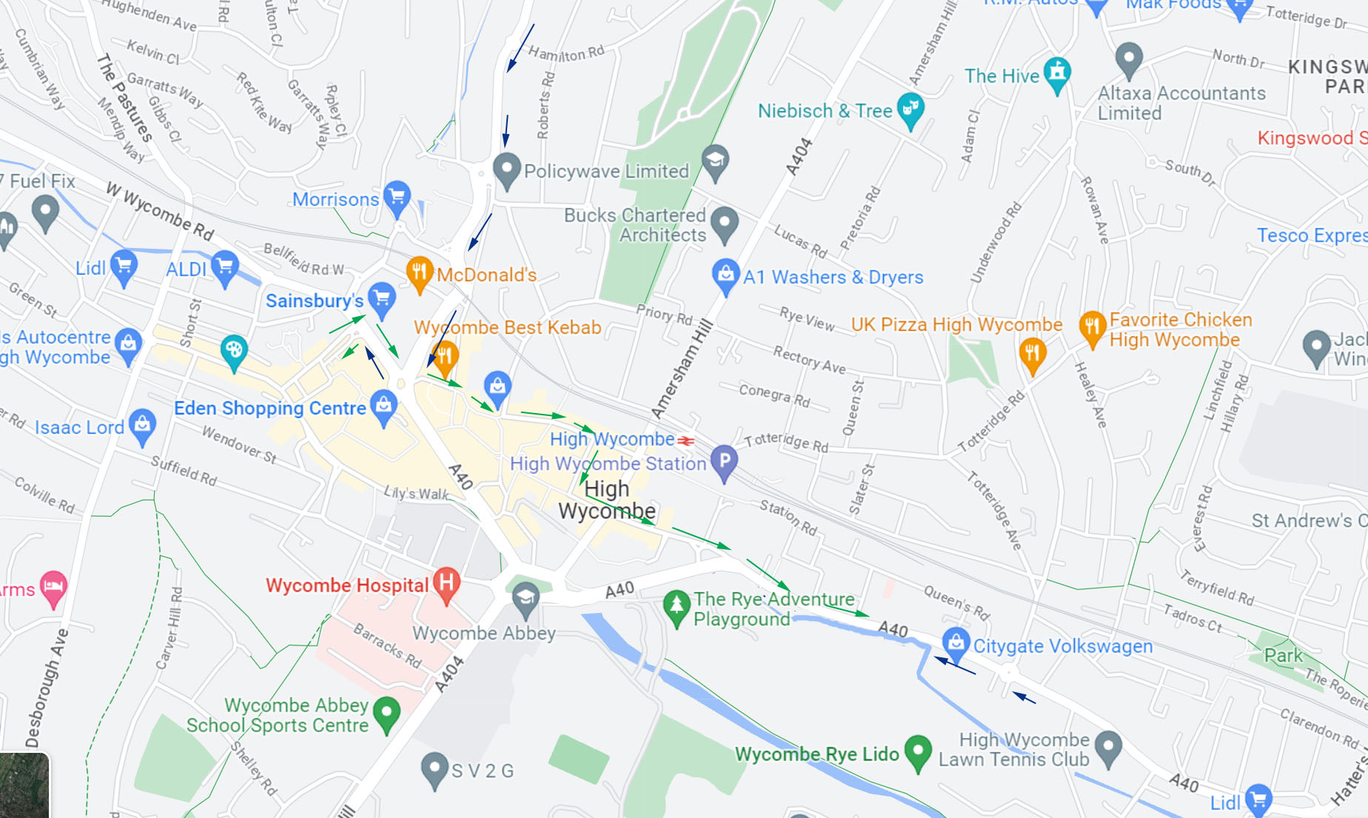
Map showing the overall route through Wycombe from RAF Wycombe

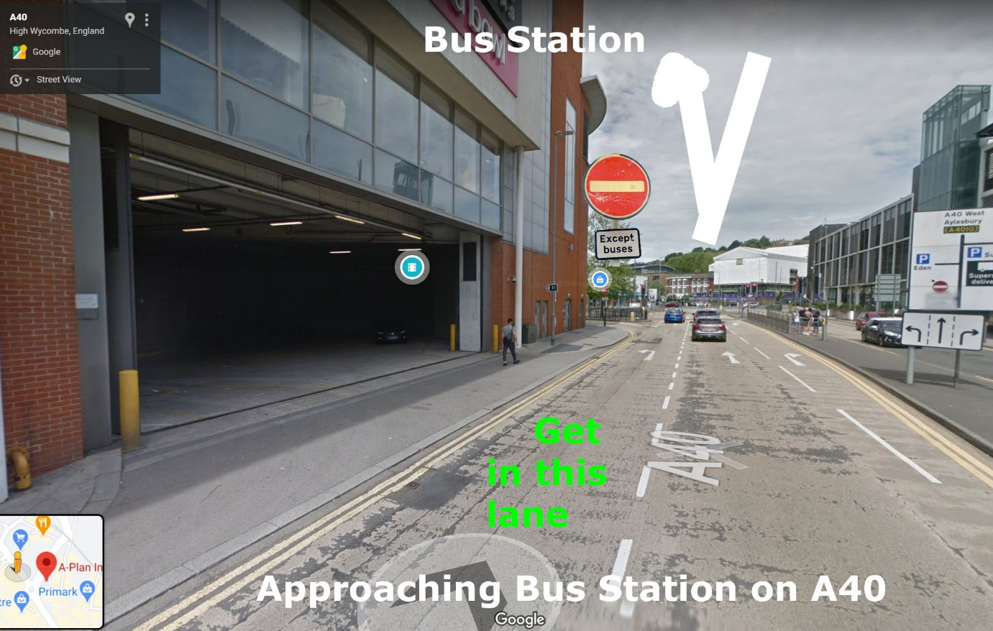
After the roundabout turn into the Bus Station.
On leaving the Bus Station head back to the Arch Way roundabout
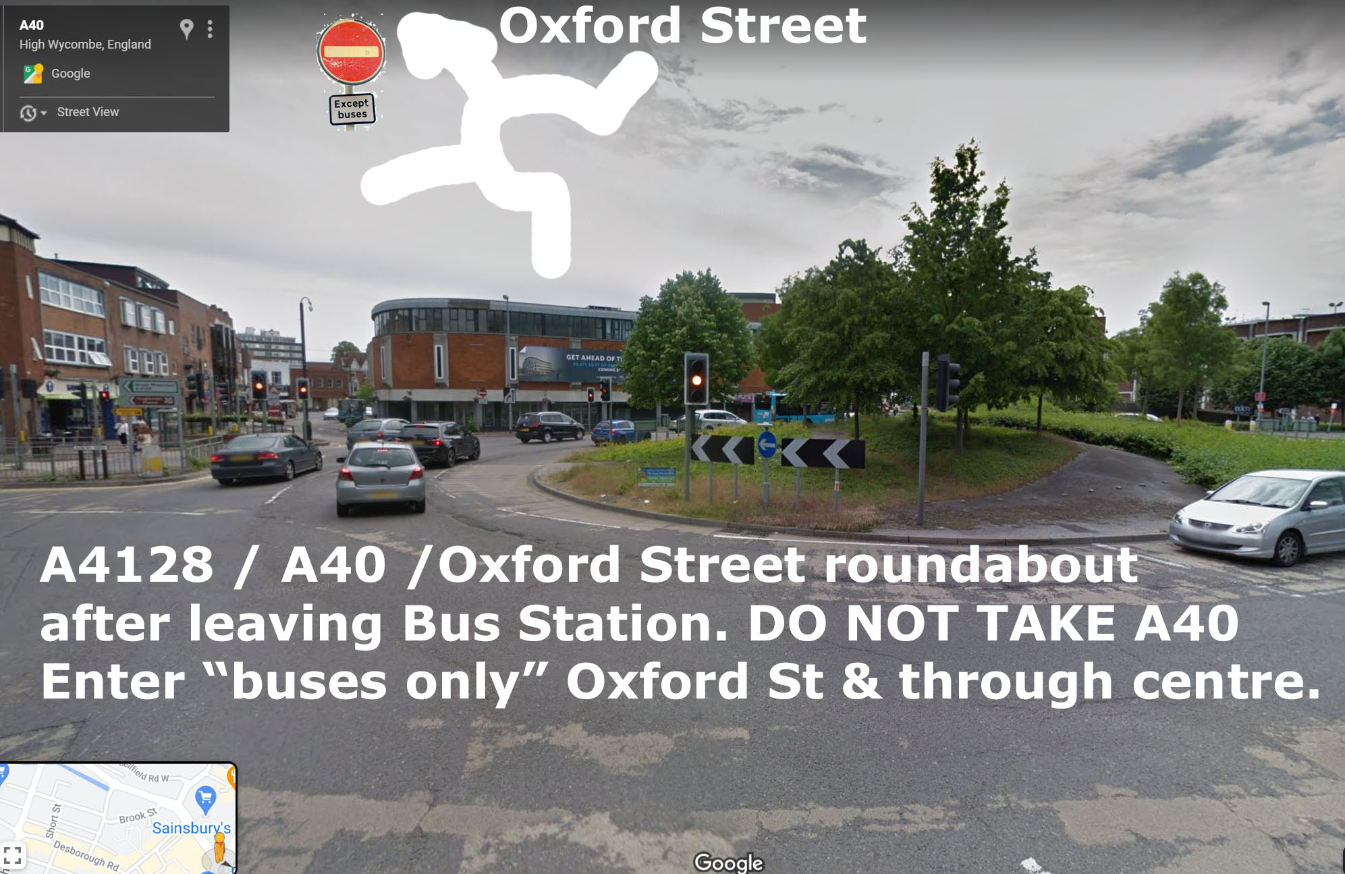At the Arch Way roundabout, this time take the second exit into Oxford Street labelled No Entry Except Buses.
Follow the “straight ahead” route through the Town Centre from Oxford Street into the narrow Church Street where buses take it in turns to get through the narrow road to the Castle Street junction by Primark. 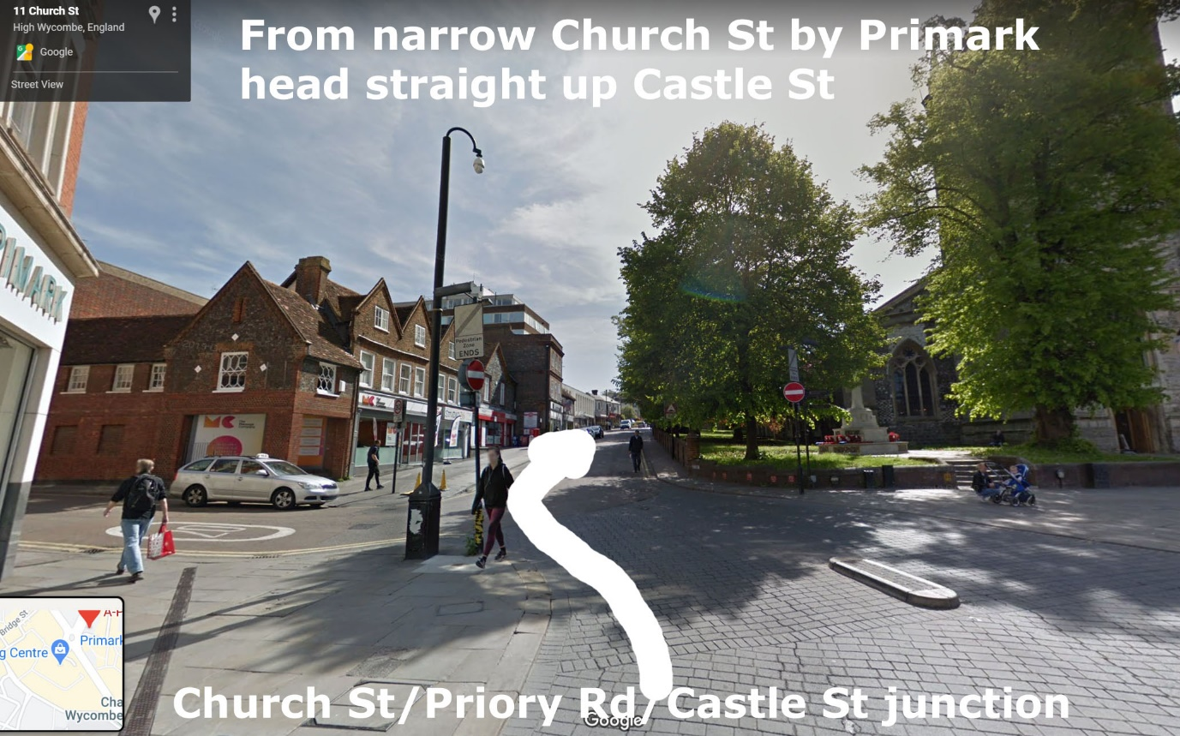
After a short distance turn RIGHT
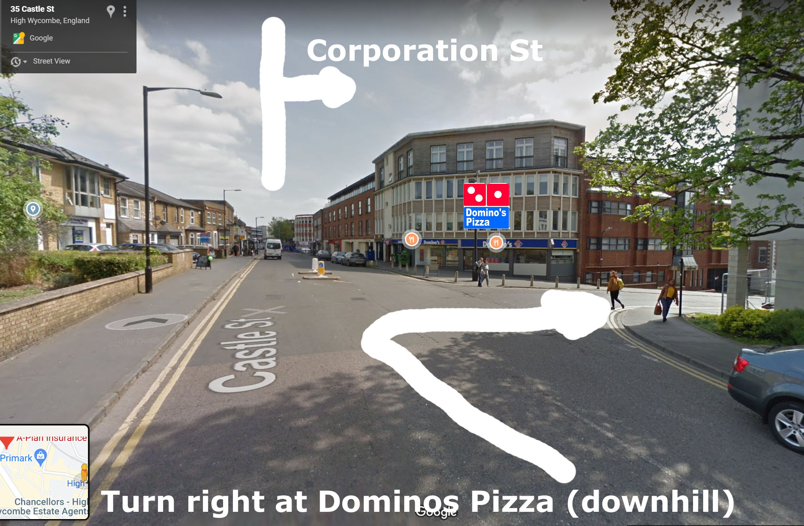
After a short distance (downhill) TURN LEFT
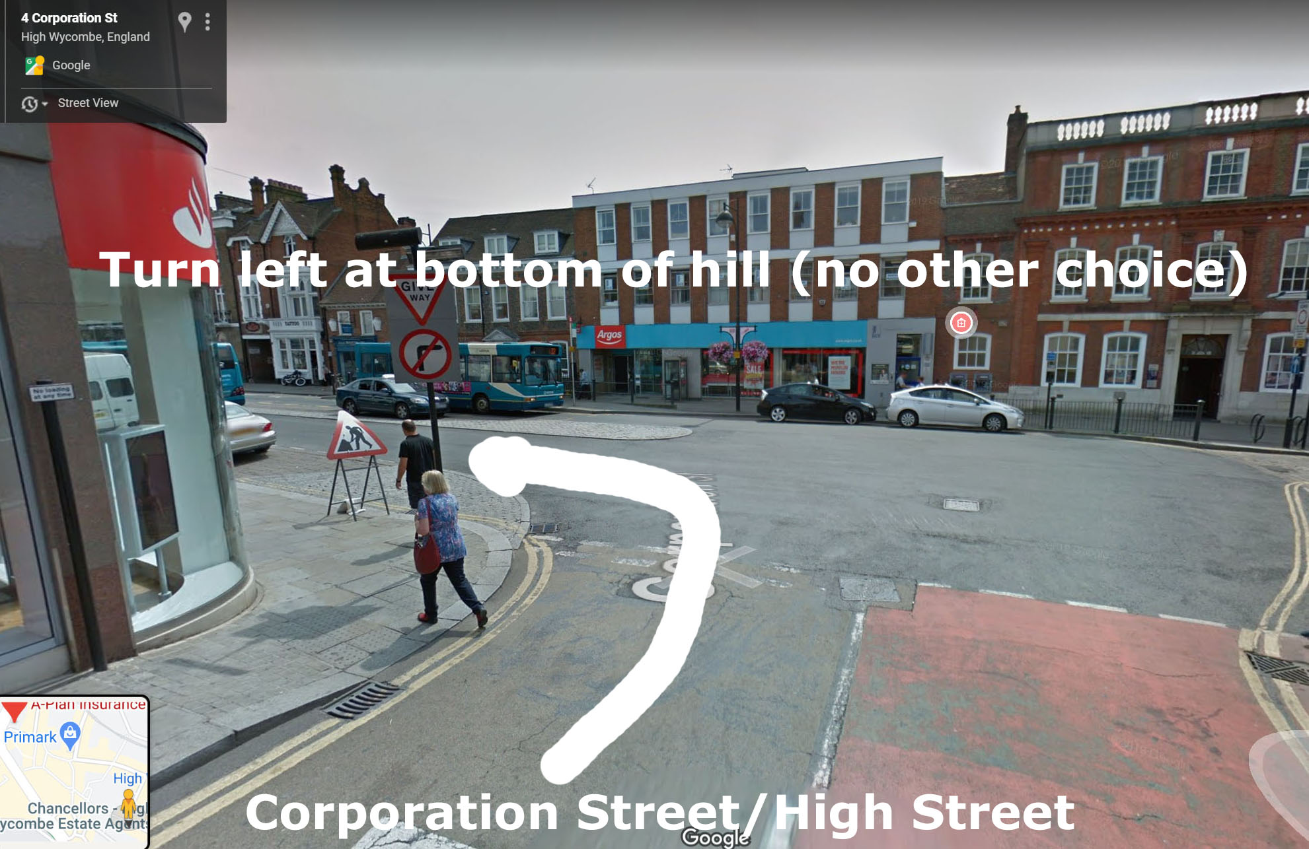

After crossing the traffic lights and a short distance VEER LEFT
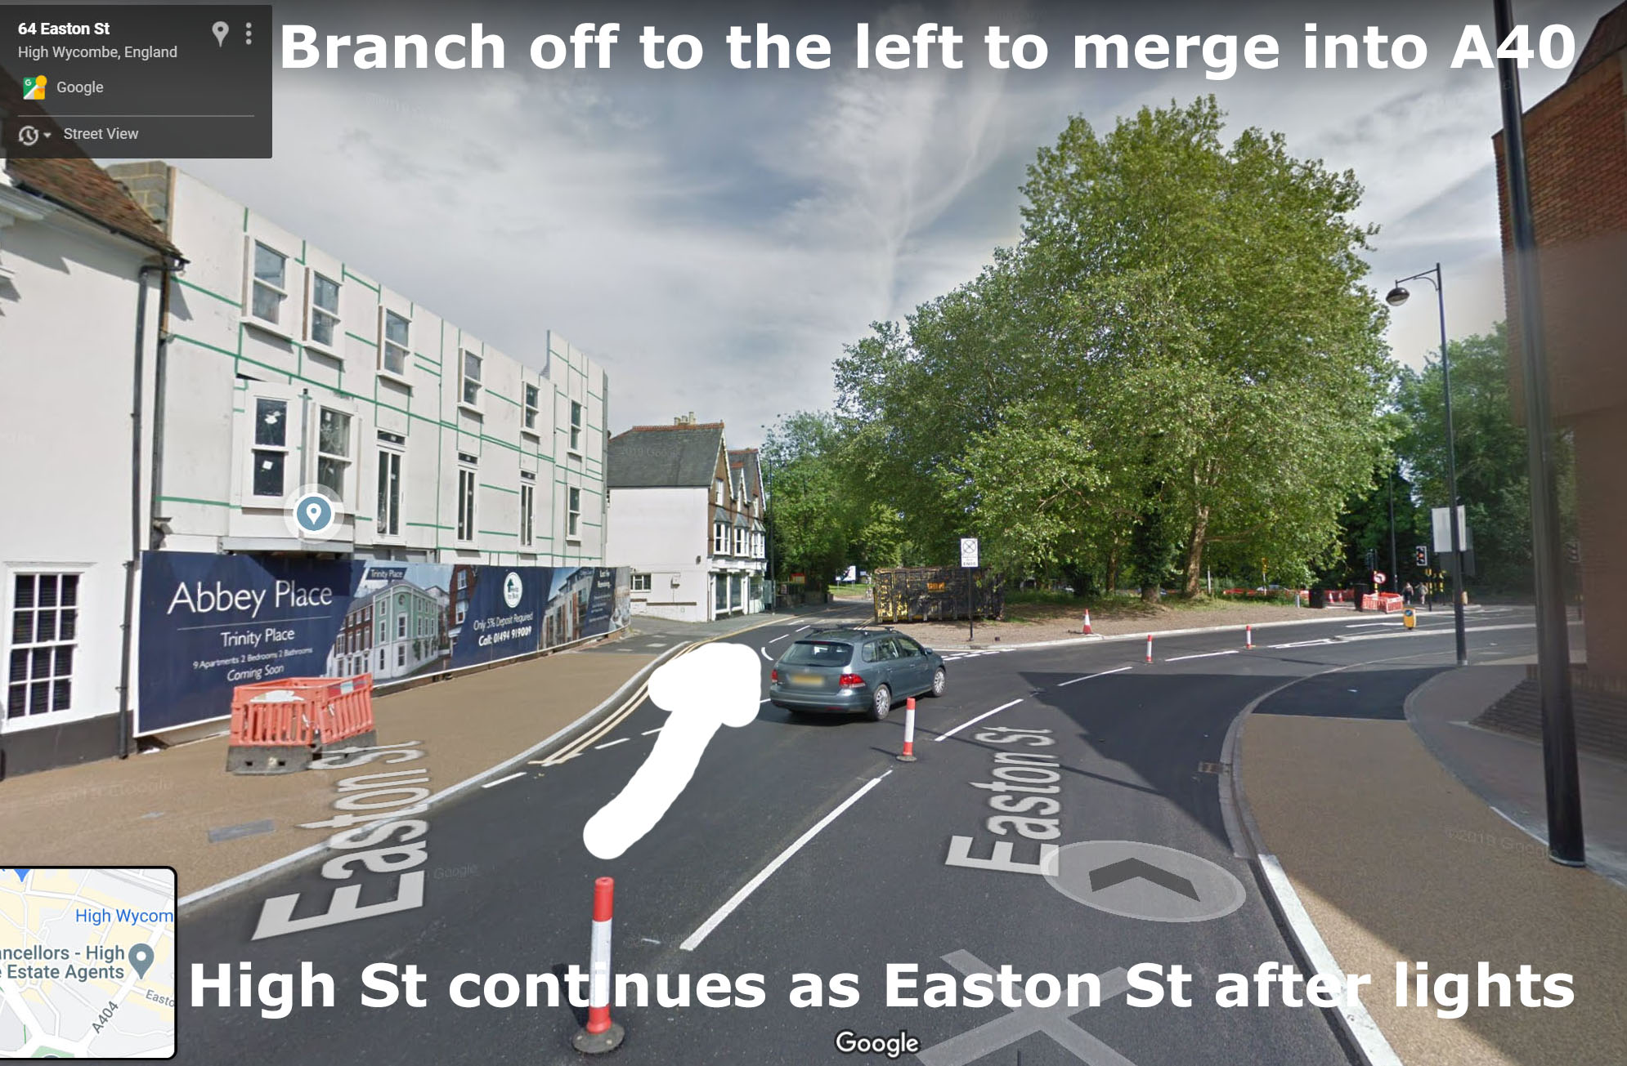
Continue out of Wycombe on A40 for 3 miles
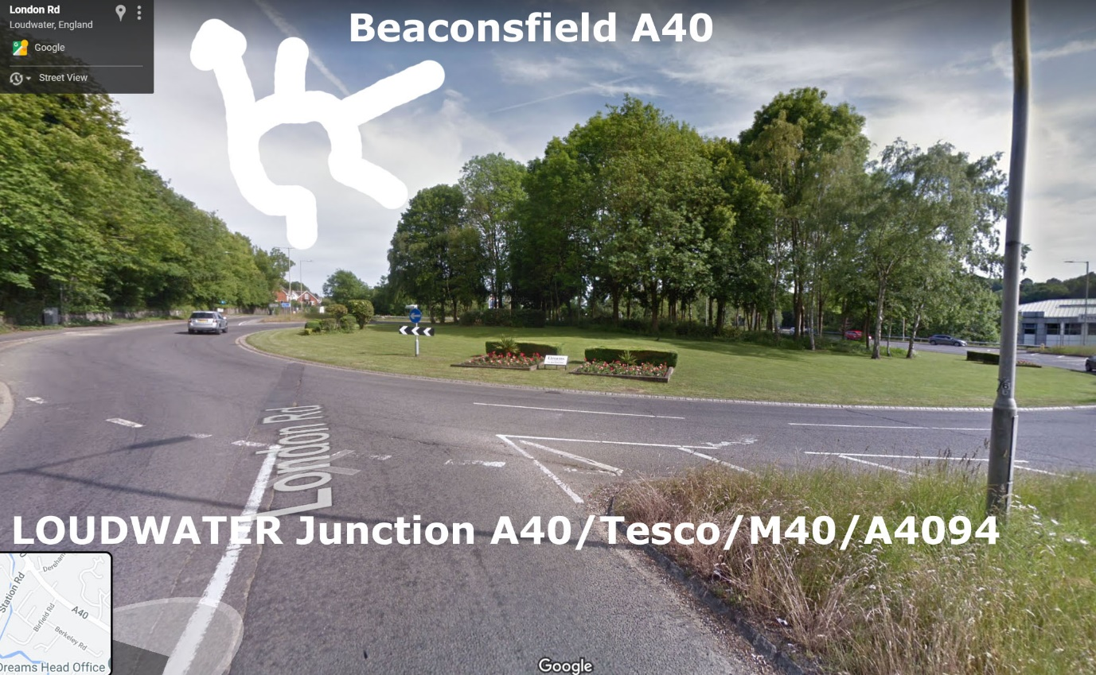
Continue on A40 for 2.5 miles to Beaconsfield
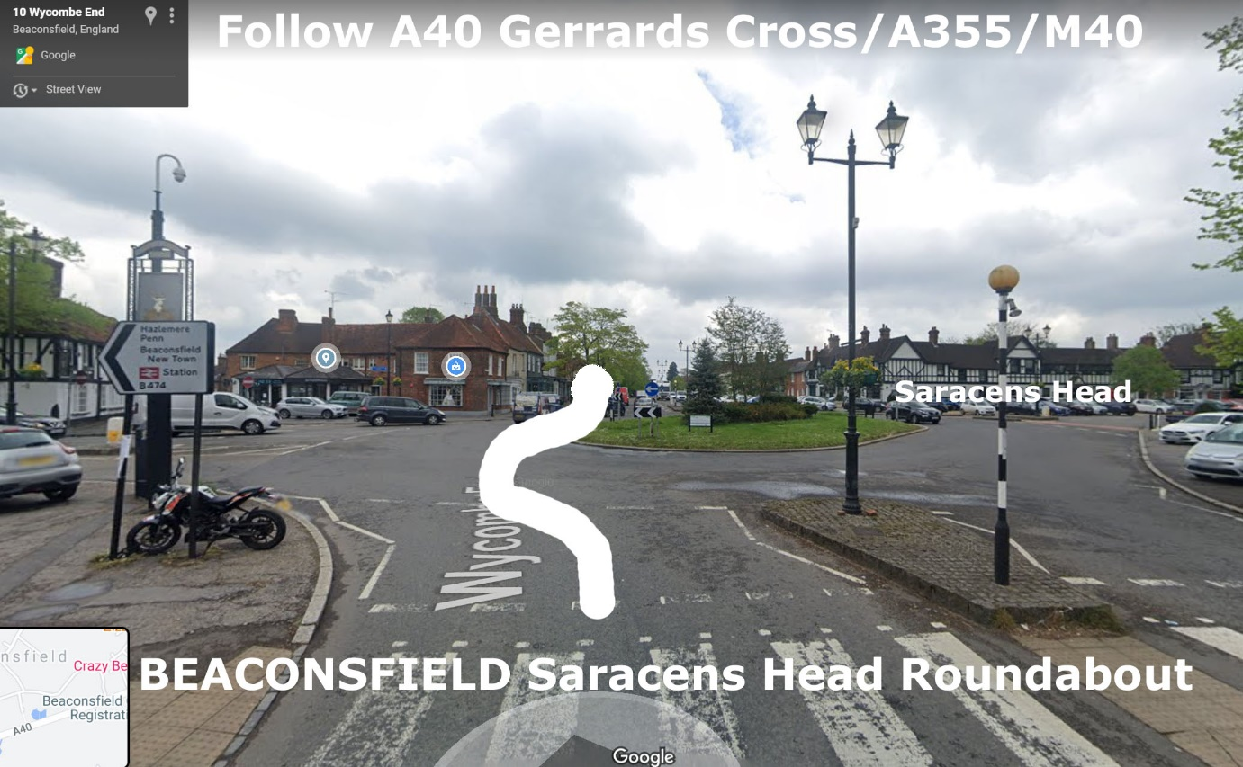
Over the roundabout to the bus stop, if running early you can wait here.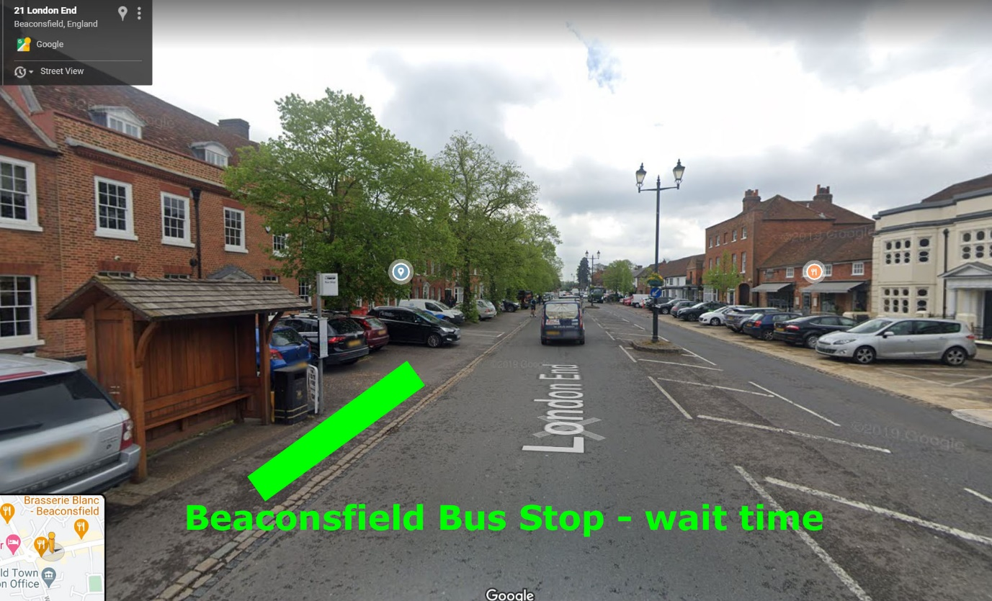
100 yards to A40/Park Lane roundabout ahead
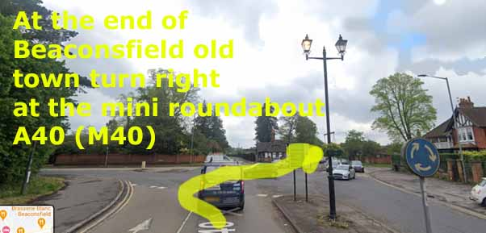
Ahead is the M40 Junction 2 roundabout.
If you are taking a break at the Beaconsfield services turn right at the roundabout, cross the M40 and use the services that are then on the left. Return to the A40 by the same route
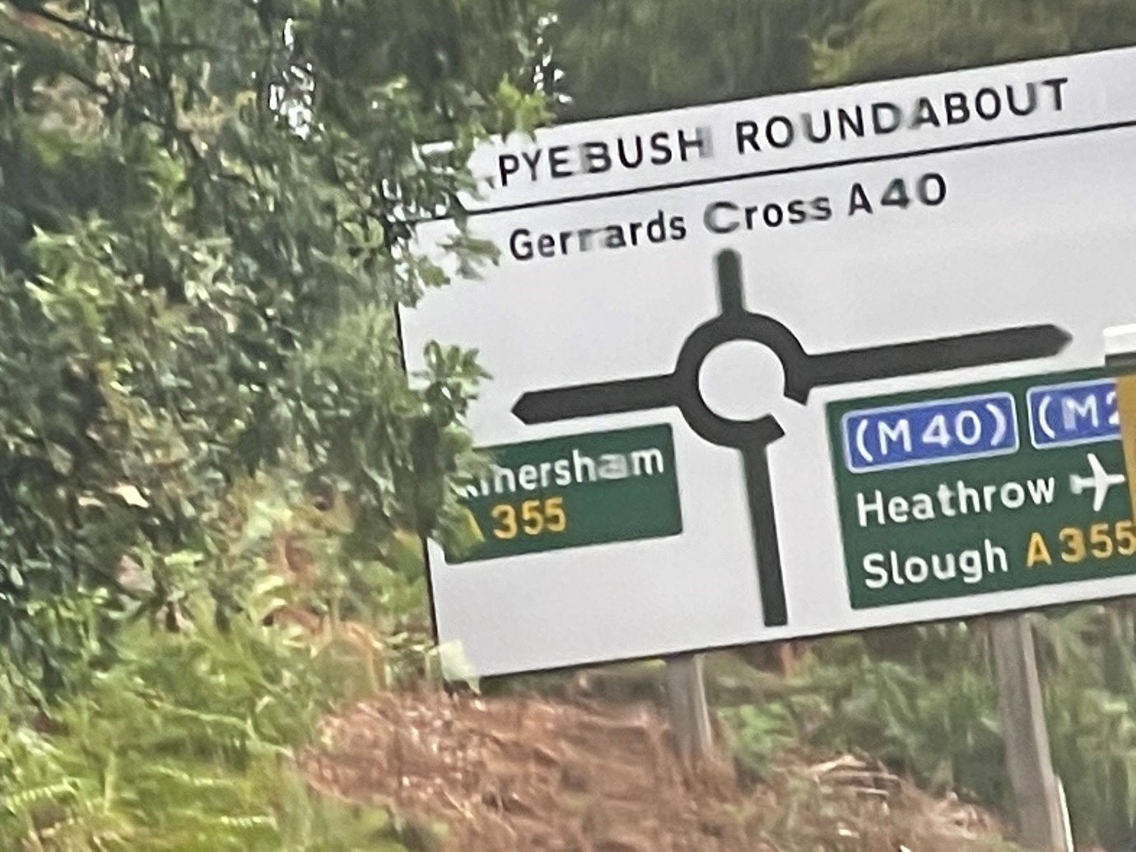
From the Motorway junction follow the A40 through Gerrards Cross and Tatling End till you meet the M40 Denham roundabout.
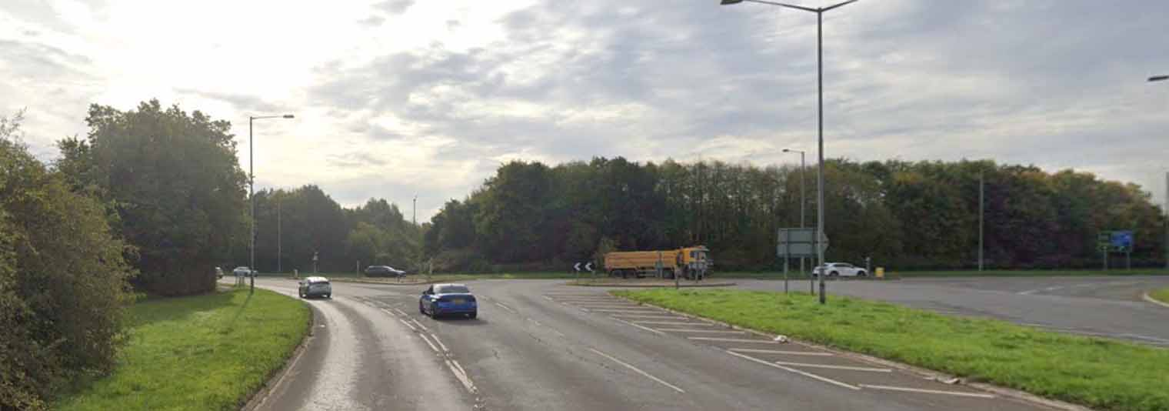
At the M40 roundabout go round clockwise or anticlockwise to the A4020 Uxbridge & New Denham exit
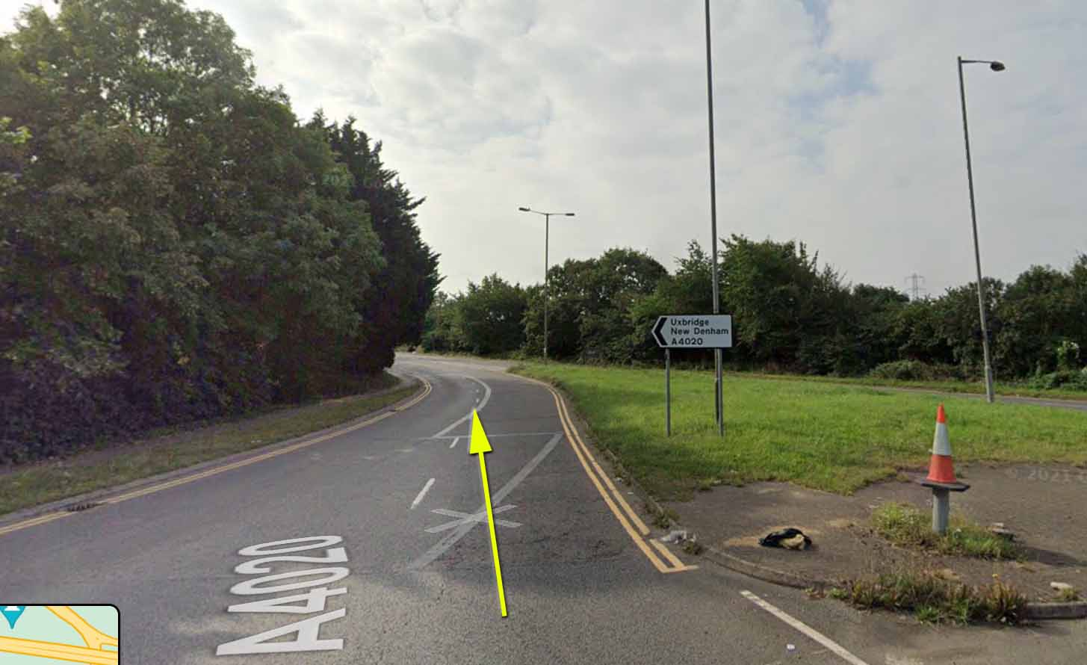
Continue along the A4020 Oxford Road until you reach the first Uxbridge roundabout
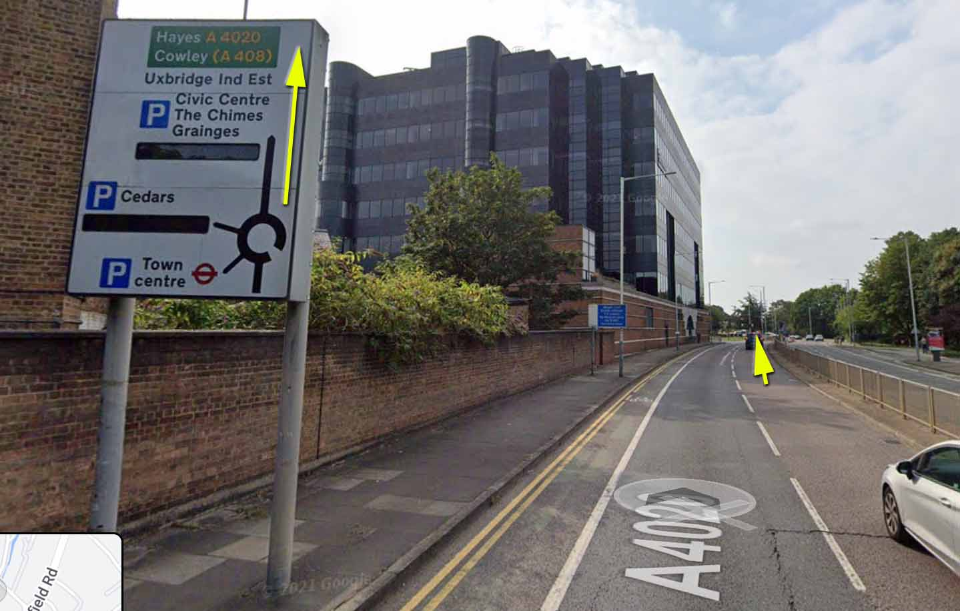
You will then come to the Cross Street gyratory.
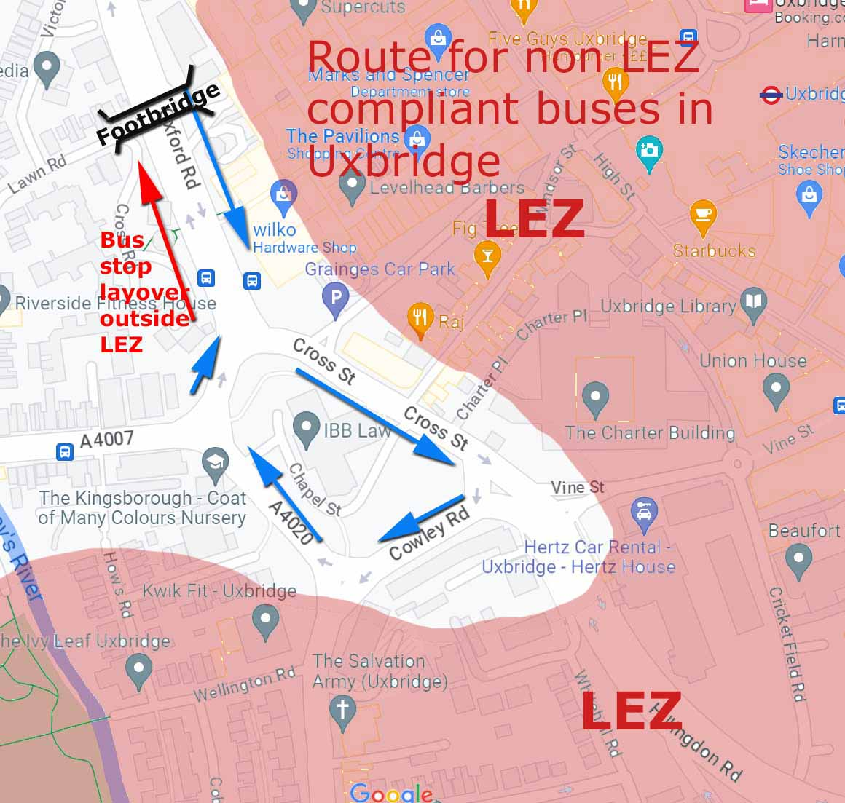

LEZ exempt buses can continue to Brunel University via A4020
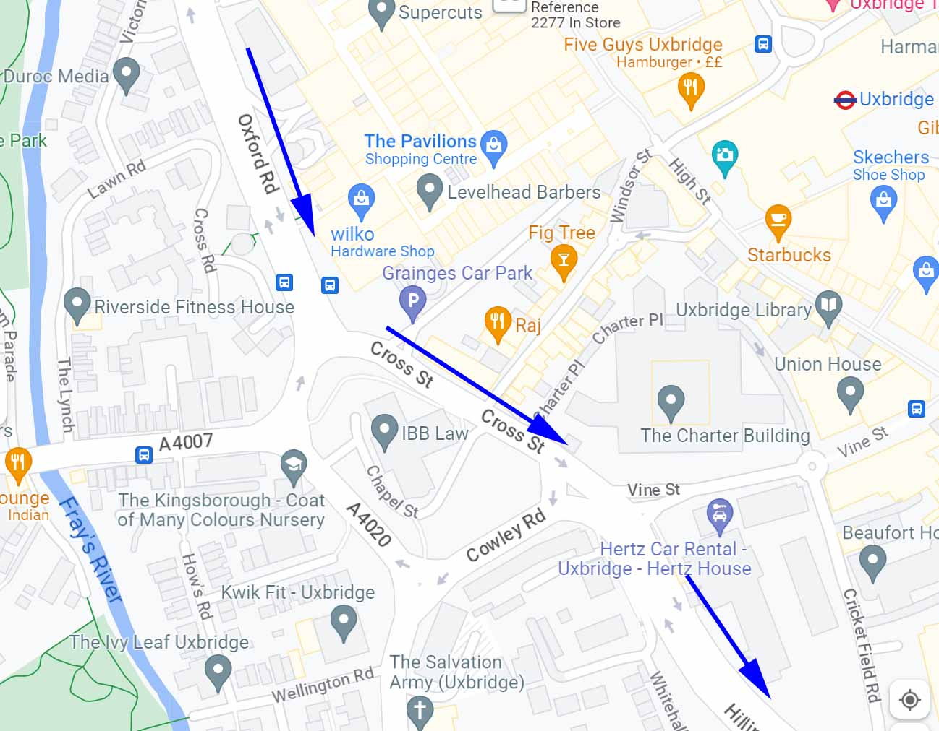
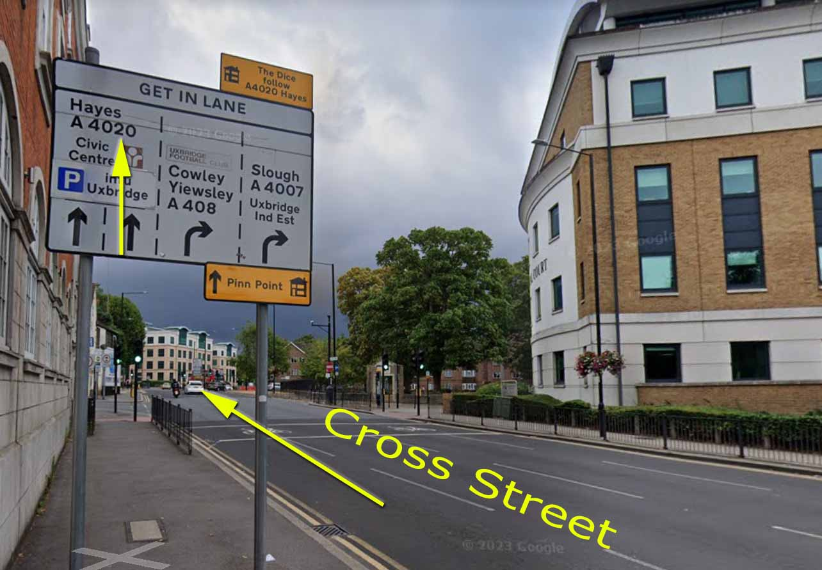
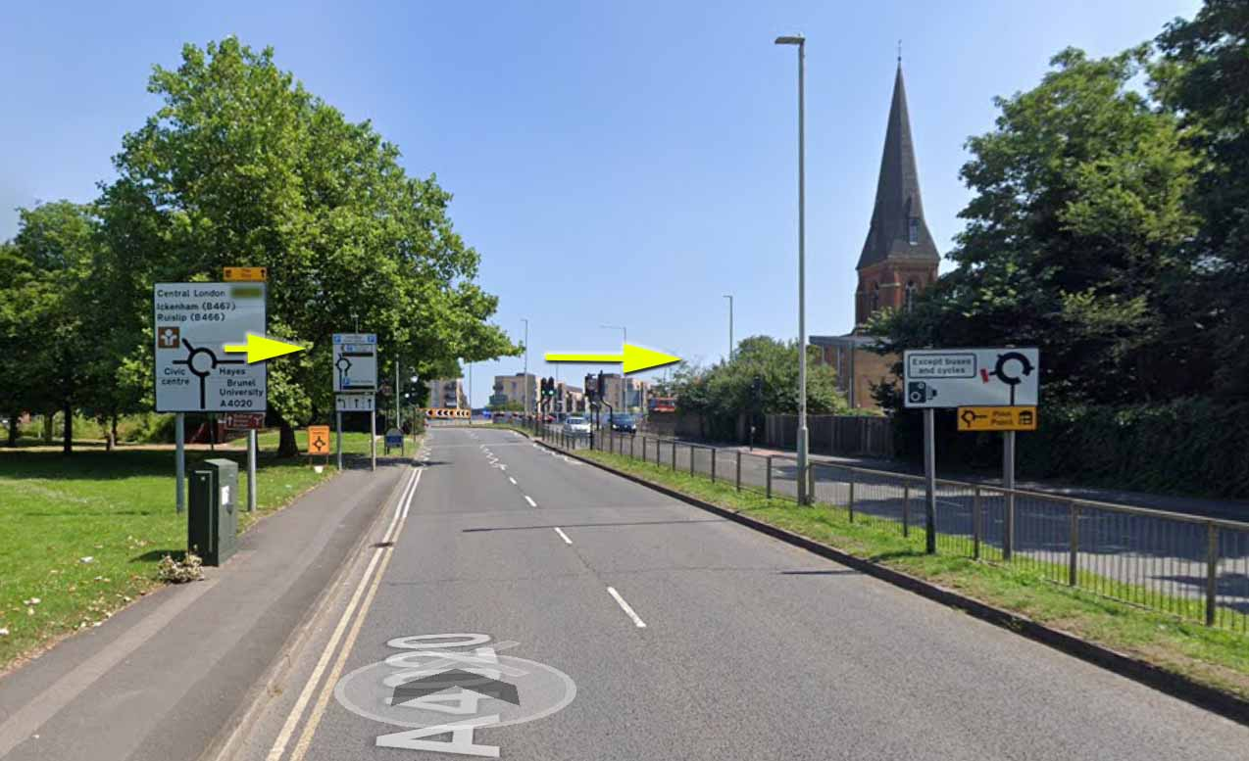
Turn RIGHT at the roundabout to Hayes & Brunel University staying on the A4020
After the first set of TRAFFIC LIGHTS get into the RIGHT HAND lane to turn RIGHT at the SECOND SET OF TRAFFIC LIGHTS (Kingston Lane)
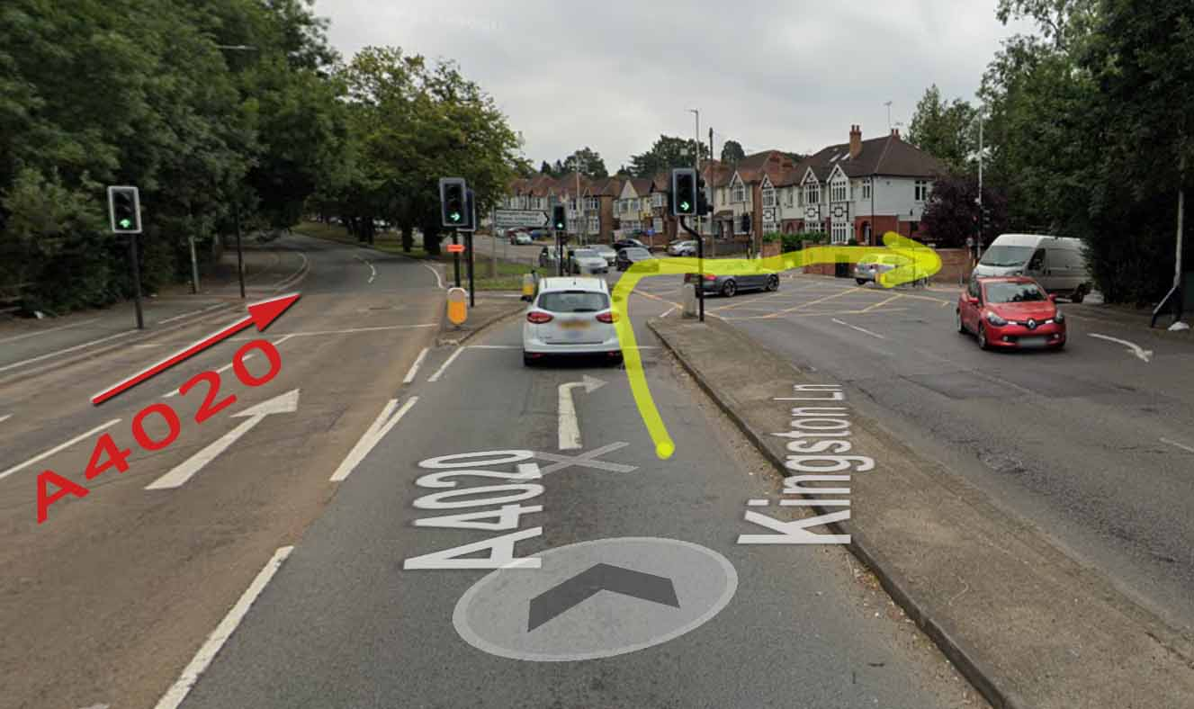
Beware there are other right turns before this but not with traffic lights.

Turn right at the roundabout into Brunel University campus.
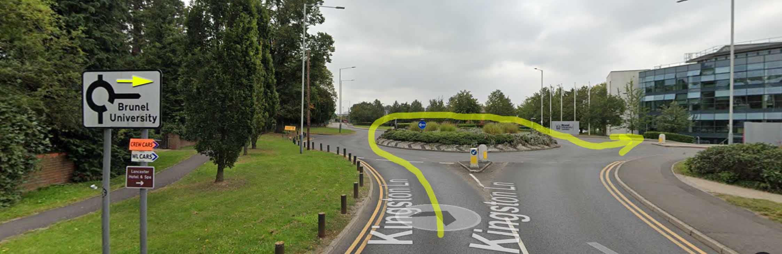
Once on the Campus you meet another roundabout, turn right and proceed around the Northern Perimeter road
